# *Lab 5 – Use Cases*

Date assigned: Friday, September 30, 2016

Date due: **Friday, September 30, 2016, 12:00 p.m.**

**Learning Objectives**

Upon successful completion of this lab exercise, the student will be able to:

* Draw use case diagrams
* Determine actors for a system
* Write use case descriptions

Save this document as a Word document named **YourUserName_E11_L05_Use_Cases.docx** in your 420-E11 folderin your home drive. The document will hold your answers for your lab. All diagrams that are drawn in Visual Paradigm or LucidChart should be pasted into this document.

To do:

1. Find and document the errors in the two use-case diagrams located at the end of the lab. **(10 marks)**

**The actors need to be outside the box, with all of the use cases inside the box. The actors are named poorly, who is Sue Smith? What is her job? The diagram is also super unorganized. There’s also no arrows on any of the relationships, so we don’t know what’s going on in the diagram.**

**In the second diagram, what are the arrows going between different actors? The report printing use case triggers other cases, but what actor is it related to? Same goes for the review previous notes use case and review text books. We can assume these are done by a student? But where’s the actor for that? There’s a lot of weird things with this diagram.**

1. Read the following description of an online college registration system, and then answer these questions. (Note that there may be extraneous information in the descriptions.)

You are developing an online college registration system. The system must enable staff of each academic department to examine the courses offered by their department, add and remove courses, and change the information about them (such as the maximum number of students). It must permit students to examine currently available courses, add and drop courses to and from their schedules, and examine the courses for which they are enrolled. Department staff must be able to print a variety of reports about the courses and the students enrolled in them. The system must ensure that no students takes too many courses and that students who have any unpaid fees are not permitted to register (assume that the fees information is stored in a separate system maintained by the university’s financial office, which the registration system accesses but does not change). **(20 marks)**

1. Define the set of actors, with their brief descriptions for the online college registration system. Store this information in a table.

|  |  |
| --- | --- |
| **Actor Name** | **Actor Description** |
| Staff | A staff member works at the college and is part of a department. They are able to view courses in their department and add or remove courses and update current courses. They must be able to print reports about their courses and the students enrolled in their courses. |
| Student | A student is enrolled in a number of courses at the college. A student may add courses to their schedule, drop courses and view course information. Students may also have loans |
| Fee system | The fee system must be able to store all current outstanding fees that a given student has and it’s data must be accessible, but cannot be modified by the course registration system |

1. Define the use cases and their brief descriptions for the online college registration system. The use case table should have three columns: the first with the name of the use case, the second with the actors/roles that will use the use case and the third with a brief (2-4 sentences) description of the use case. Make sure that the use cases have proper names with a strong action (verb) followed by a noun (e.g. Manage Account).

|  |  |  |
| --- | --- | --- |
| **Use Case Name** | **Actors** | **Use Case Description** |
| Add course | Staff | A staff member must be able to add a new course to the department |
| Remove course | Staff | A staff member must be able to remove an old course from the department |
| Update course info | Staff | A staff member must be able to update the course information for a course in their department |
| Print course report | Staff | A staff member must be able to view and print out info for any of the courses in their department |
| Print student info | Staff | A staff member must be able to view and print our info for any student enrolled in a course from their department |
| Add course | Student | A student must be able to add a course to their schedule |
| Remove course | Student | A student must be able to remove a course from their schedule |
| View course info | Student | A student must be able to view all the information for any courses in which they’re enrolled |
| View all courses | Student | A student must be able to view a list of all courses in the college in which there is currently space available in their schedule. |
| Store outstanding fees | Fee system | The fee system must be able to store any outstanding fees that any students might have |
| Deny students access | Fee system | Should a student have any unpaid fees, the fee system should be able to deny them enrollment |
| Allow read access | Fee system | Other college systems should have access to view the fee system’s data, but should not be able to make edits to the data. |

1. After you determine the actors and use cases, draw the use case diagram in Visual Paradigm or LucidChart. Paste the diagram into this lab.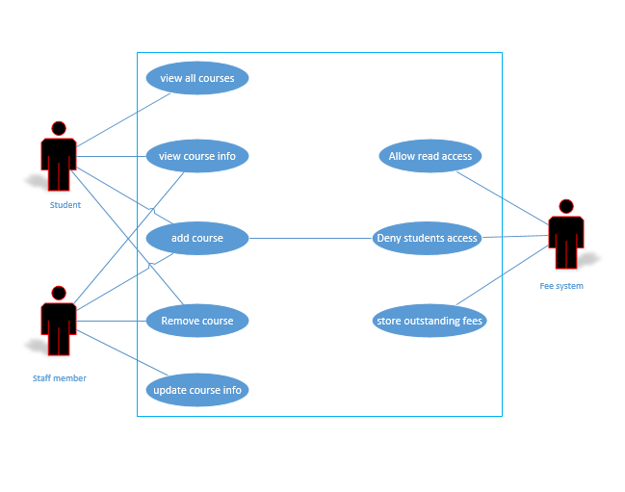
2. Read the following description of a video store system, and then answer these questions. (Note that there may be extraneous information in the descriptions.)

A Video Store (AVS) runs a series of fairly standard video stores. Before a video can be put on the shelf, it must be catalogued and entered into the video database. Every customer must have a valid AVS customer card in order to rent a video. Customers rent videos for three days at a time. Every time a customer rents a video, the system must ensure that he or she does not have any overdue videos. If so, the overdue videos must be returned to the store and the overdue fee paid before the customer can rent more videos. Likewise, if the customer has returned overdue videos but has not paid the overdue fee, the fee must be paid before new videos can be rented. Every morning the store manager prints a report that lists overdue videos. If a video is two or more days overdue, the manager calls the customer to remind him or her to return the video. If a video is returned in damaged condition, the manager removes it from the video database and may sometimes charge the customer. When a customer rents a video he or she may pay by cash, Interac or Credit Card. When paying by credit card, the system must check with the credit bureau to make sure that the customer has credit. When paying by Interac the system must connect to the Interac system. **(20 marks)**

1. Define the set of actors, with their brief descriptions for the video store system. Store this information in a table.

|  |  |
| --- | --- |
| **Actor Name** | **Actor Description** |
| Customer | A customer must have a valid AVS customer card to rent a video. Customers can rent videos for 3 days at a time and may end up with overdue rentals. A customer must pay for the video and may do so with multiple different payment methods. |
| Manager | A manager prints out a list every morning of overdue videos. A manager will call customers if their videos are very overdue. A staff member may charge a customer for returning a damaged video. |
| Employee | A staff member must add to the system any new videos that the store gets in and remove any old or damaged ones. |
| Credit bureau | The credit bureau must tell the system whether or not the customer has valid credit to rent out the video. |

1. Define the use cases and their brief descriptions for the video store system. Store this information in a table.

|  |  |  |
| --- | --- | --- |
| **Use Case Name** | **Actors** | **Use Case Description** |
| Rent video | Customer | A customer can rent a video |
| Return video | Customer | A customer who rents a video, must return a video |
| Pay for video | Customer | A customer who rents a video must pay for it. |
| Prints list of overdue videos | Manager | Every morning the manager prints out a list of all overdue videos. |
| Call overdue customers | Manager | If a customer has been overdue for more than 2 days, the manager calls the customer to bitch |
| Charge for damaged videos | Manager | If a video is returned damaged, a manager can charge them extra for the damage |
| Add videos to the system | Manager | A manager can add videos to the DB before they get added to the shelves. |
| Remove videos from system | Manager | A manager can remove videos from the DB if they get returned too damaged to rent out. |
| Charge for damaged videos | Staff | If a video is returned damaged, an employee can charge them extra for the damage |
| Add videos to system | Staff | A staff member can add videos to the DB before they get added to the shelves. |
| Remove videos from system | Staff | A staff member can remove videos from the DB if they get returned too damaged to rent out. |
| Confirm credit | Credit bureau | The credit bureau confirms a customer’s credit when they pay by credit |

1. After you determine the actors and use cases, draw the use case diagram in Visual Paradigm or LucidChart. Paste the diagram into this lab.

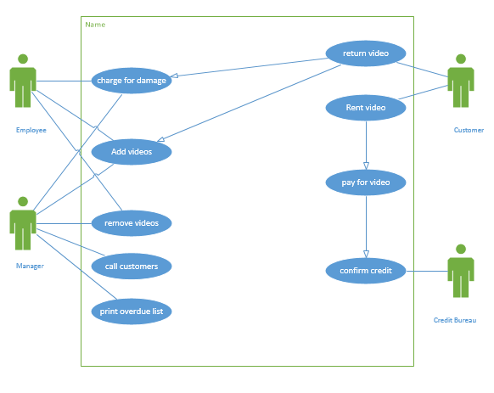

**To submit**

When you have completed the exercise upload the files to the Moodle page for this course.

1. **Online Shopping Use Case Diagram (10 marks)**

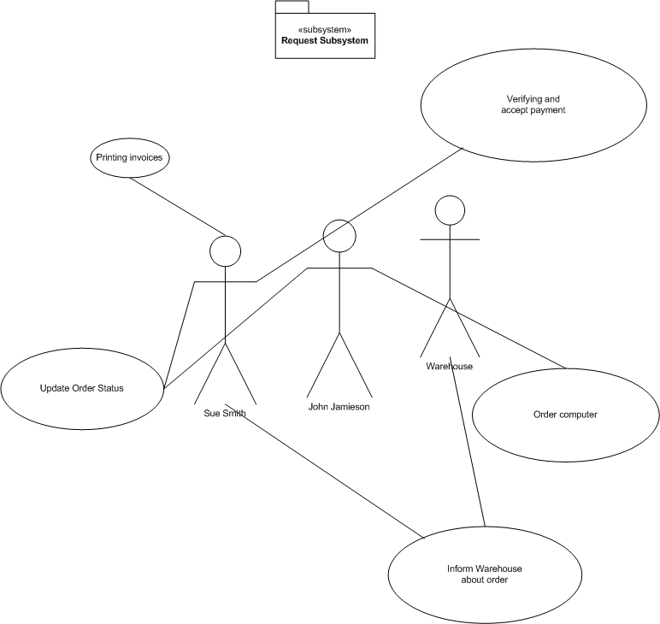

1. **Generalizations (10 Marks)**

